道歉信

Dear ________,

I am writing this letter in purpose of expressing my sincere apology to you. I feel terribly sorry. But I hope you can forgive me if you know the reason.

另起一段写一两句原因。

Once again, I am very sorry for any inconvenience caused. I will appreciate if you can accept my apology and understand my situation. In order to compensate to you / for my absence / mistake / carelessness, I hope you can allow me to have the opportunity to say sorry in person recently. I am looking forward to your earlier reply.

Yours sincerely,

Wang Wei

建议信

Dear________,

I am writing this letter in purpose of providing some conductive suggestions.

In my opinion, it is essential for you to take the following actions. First of all, it will be useful for you to _________________. Furthermore, you had better

___________. Most important of all, if you can __________, I am sure it is very sensible.

I hope you will find these proposals useful (effective), and I would be ready to discuss this matter with you to further details. I am looking forward to your earlier reply.

Yours sincerely,

Wang Wei

通知（Notice）
To improve people’s/student’s ability to 目的 , 活动名 is going to be held in early July/this weekend（时间地点）.

Those who are interested in this __活动___ are welcomed. For the applicants longing for joining this _ 活 动 ___, one has to be familiar with the requirements of this activity/program/contest. Some activities include____, ____ and _____. Online applications for taking part in this activity/program/contest are available now.

Please call 123456 for application and information of this activity/program/contest . You are highly welcome to join us.

Summer Camp Organizer

May 1, 2015

祝贺信

Dear________,

I’m writing this letter for the purpose of showing my congratulations on your success.We are happy to know that_____________(祝贺的事件内容，可由题干改写）.Your hard work has paid off and we’re all so proud of you.

I have been watching your progress with admiration all the years, and I know more than anyone else how much effort you have put in.I really believe that you deserve the success you have made. What’s more, I am also confident that in the near future you will abstain greater achievement.

May all the years ahead fulfil your dream!

Yours sincerely,

Zhang Wei

感谢+邀请信

Dear________,

I would like to express my heartfelt gratitude to you for _your generous help___（或者感谢的原因，可由题干改写）. Without your assistance things would not go so well.

Your kindness has made_________(具体事件，或者直接可用代词 it) an unforgettable experience, which is highly admired by my friends after I share this with them. By taking this opportunity, I would love to invite you to China for a visit at your convenience, so that I could have the chance to repay your kindness.

Once again, please accept my sincere thanks. I am looking forward to your reply. Yours sincerely,
Zhang Wei

投诉信（商品类）

Dear Sir or Madam,

I’m writing this letter for the purpose of making a complaint about __________(投诉的具体内容，可由题干改写，或者直接用 product 替代） which I bought from your online store last Tuesday.

It’s a brand new product. However, when I received it, I found many problems. Being a regular and loyal customer of your store, I’m quite disappointed about this. The problems are as follows. To begin with, ____________（商品问题之一）, which gives me much inconvenience and trouble. In addition, ____________（商品问题之二）.

I strongly request that it can be replaced or refunded. I will highly appreciate if you can solve this problem. I’m looking forward to your reply.

Yours sincerely,

Zhang Wei

英语二---大作文

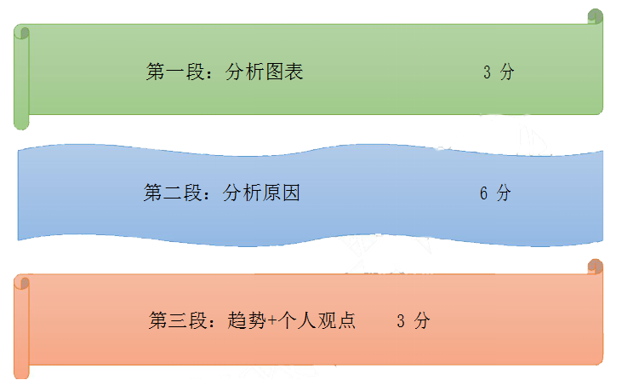

静态图 第一段

The chart above depicts the differences(changes) of ___主题________. As is revealed by the chart, the percentage of _______was the largest among all the categories ,accounting for ____%. In comparison ,______and _______took up_____%, _____% and ____% respectively.

趋势图 第一段（二选一）

- As can be seen from this chart, great changes have taken place with regard to

______. ______has been increased/decreased from 数字 in 年 to 数字 in

- ,while the number of _______ remains almost the same.

2. As can be observed from the above chart, some important changes have taken

place in the past few years （ decades) with regard to ___ 主题 ___________.

Clearly, ____主题 has(have) kept growing / rising /increasing / expanding , from ____ in the year of ____ to ______, whereas （meanwhile, ） __主题_____ has (have) been on the steady decline / drop / fall / decrease / shrinkage from _____ to

_____ during the same period. It can also be found that____ 主题 ______ have remained more or less unchanged during the same period.

第二段：承上启下句+原因分析

承上启下句（四选一）：

- When it comes to the reasons for the changes(differences), different people give different explanations. I think the following ones are the most important.

- It is of no difficulty for us to come up with some factors responsible for these changes(differences).

- The contributing factors for this phenomenon can be summarized as follows.

- What contributes to the above changes(differences)? Some factors need be carefully examined below.

原因分析：

主题如果是积极的，可以用如下原因：
1. Thanks to the policy of reform and opening-up, the national economy has been developing at a considerably high speed in the past years which contributes to these changes.

2. Furthermore, people’s living standard is increasingly bettering off and people now have enough money to make their life more convenient and comfortable.

3. With the rapid economic growth of china, we must admit that this trend is largely related to the positive guidance of the central government.

4. It can help broaden our eyes and expand our knowledge.
5. There is no doubt that it can make our lives more convenient and more comfortable than before.
6. It is obvious that people are attaching greater importance to the quality of their life.
主题如果是消极的，可以用如下原因：
7. People’s ill attitude and improper behaviors become the leading cause of this phenomenon.
8. Lack of government policies and supervisions will definitely exert a negative influence on it.
9. There are not enough instructions and regulations to guide people to avoid these problems.

第三段(二选一）

1. Taking into account the points discussed so far . we can conclude that with the development of society ,the trend/phenomenon is bound to continue for a few years in the future. As far as I am concerned, it’s a positive (negative) not merely to individuals but to the whole society.

- As discussed above, it is no surprise to see this difference. And I firmly believe that this established trend will continue for quite a while in the forthcoming years.

